Dear [Name],

First of all, I want to thank you both for a wonderful year, and for the flexibility you’ve offered on masks during summer camps.

With that in mind, as schools are making decisions around what to do with masks in the fall, I’d like to share our preferences. This has become such a polarizing topic, that I think many people who might not want to have their kids in masks, will be shy about standing up. So, I’m going to stand up and share my thoughts 😊

As you are no doubt aware both DESE and the governor have not mandated masks, but have instead made a strong recommendation that students and staff mask. Governor Baker reiterated this in his recent press conference. There is a world of difference between a mandate and a strong recommendation. The CDC strongly recommends that people not eat raw fish or under-cooked meat, and yet many people—especially in this state—choose to enjoy our oysters raw. My hope is that [your school] will embrace the flexibility offered in this “strong recommendation” and not mandate masks—or distancing—for students in any setting.

I believe the data is firmly on the side of this position. The policy response to COVID—particularly as applied to children—has been wickedly inept. We now have nearly a year-and-a-half’s worth of data. Not to use that data to craft better policies and create better outcomes for our children, would be simply wicked.

That data tells us several key things that argue strongly against masking children. To wit (all of these claims are supported with data and links below):

- Children are at extremely low risk from death, hospitalization, or other adverse events due to COVID-19. They face a 3-4x higher mortality risk from flu vs. COVID, and a 10x risk of suicide.
- Even with Delta, children are at extremely low risk, with some data suggesting that pediatric hospitalization rates for Delta are less than half what they were for earlier variants.
- Children are NOT super-spreaders. They are not the reservoir of COVID-19 that is “prolonging the pandemic”. Multiple contact tracing studies have shown that the R0 for children is actually BELOW one, meaning it is mathematically impossible for them to drive this epidemic. They are epidemiological dead ends.
- Mask mandates--especially in schools--do not reduce school or community transmission.

With these facts in hand, it becomes clear that if we are to continue masking children for COVID with vaccines universally available to the at-risk, there will be no logical point at which we can un-mask them. Even with widespread vaccination of children for COVID-19, using the arguments currently in vogue, the greater lethality of flu would council permanent masking to limit its spread (never mind CDC analyses showing that doing so does not limit its transmission). If we do not take this off-ramp for masking, there will be no other.

Supporting data:

Children are extremely low risk from COVID:
As of now, there are 332 deaths of children with COVID in the U.S. This compares to about 450/year in a normal flu season—and remember, these 332 deaths occurred during TWO COVID seasons. Beyond this, the CDC has noted that 35% of these deaths could not possibly have had anything to do with COVID (e.g., they were car accidents, suicides, etc., etc..). Thus, the actual number is not possibly above 219. Of these, virtually all were extremely ill. Researchers from Johns Hopkins recently found a mortality rate of zero for children who were not extremely ill with prior conditions, like leukemia. Nor does this reflect lower spread due to our world-breaking interventions. The CDC estimates that through May, 2021 there were 27 million COVID infections in children (23 million symptomatic). Using the number of deaths where COVID might actually have been causal, this yields a maximum infection fatality rate (IFR) of 0.001% for symptomatic infection in children. This compares to around 12.5 million symptomatic flu infections in the same age group in any given year, which with an average of 450 deaths, yields an IFR of 0.003%. Thus COVID is significantly less dangerous for children than flu—3-4x less deadly depending on the year—even without a vaccine. The risk of hospitalization is also miniscule. Again, on 23 million symptomatic infections, the CDC estimates there to have been 209,000 pediatric hospitalizations—a rate of 0.9%. The rate for flu is ~0.4%, approximately half that of COVID. However, here, too, there are caveats. A recent study found that 45% of pediatric COVID hospitalizations were in no way related to COVID. This would bring pediatric hospitalization rates for COVID in-line with those for flu. There is of course the question of “Long COVID” in kids. Once again, there is much more heat than light here. In a recent study, researchers found no difference in long-COVID symptoms in children who had antibodies for COVID, vs. those who did not—i.e. those who were never infected. This study found the same. From all of these data, it should be clear that at a minimum, if we are going to mask children to prevent COVID, logically, we must mask them for flu as well. Is that what we want? What are the trade offs? When it comes to children, their risk of death from suicide (under normal circumstances) is nearly 10-fold higher than their risk of death from COVID. I did not choose this statistic at random—I believe this is a potential trade-off to masks that is not being considered. The sense of isolation and alienation created by masks seems likely to aggravate this much more serious risk. If the risk of suicide were increased by masking and distancing by even 1%, it would need to be offset by a reduction in pediatric COVID deaths by at least 10%. Given the very fragile nature of the children who have died from COVID, that is extremely unlikely. Unfortunately, no concern has been given to the potential downsides of masks by public health officials, especially when it comes to children.

Delta has NOT changed the game. Children are STILL at extremely low risk from hospitalization or death from COVID.
The same applies for Delta, which while more transmissible, appears to be less deadly, not more, for children. In the UK, where Delta has come and gone, and hospitalization rates for children with delta were nearly 50% lower. Data from the CDC shows that pediatric hospitalizations are at nearly identical levels as last year at this time, and significantly lower than winter peaks. The most recent data from HHS shows just 2 pediatric hospitalizations in Massachusetts—and a winter peak of just 20 out of a population of 1.5 million children in the state.

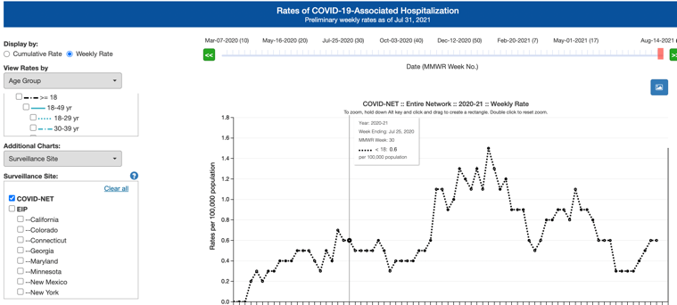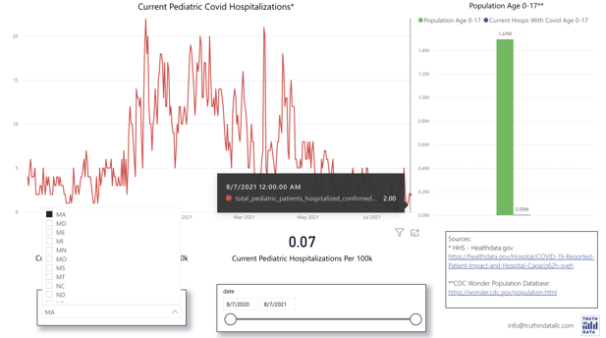

Children are not Super-Spreaders—Even Unvaccinated
The original rationale for masking kids was that they were super-spreaders—that while they wouldn’t get sick, they might kill grandma. In fact, they are not. This study from the CDC found that each student infected generated an additional 0.77 infections (27 student infections, yielded 21 additional infections clearly related to a student), where each teacher generated an additional 2.6 infections—3.4 times the rate of the children. This is important, because it shows that children are effectively dead ends when it comes to transmission—even unvaccinated. 0.77 is effectively the R0 for children, meaning that they CANNOT be responsible for driving community transmission. A similar—but much larger—study of 400,000 children in Germany found that children generated just 0.25 cases for each infection, where teachers generated 1.1—4-fold more. Interestingly, the children were not masked in this study, except for at the end, when cases rose significantly. Children’s lower transmission rates appear to protect not just them, but those around them. In Florida, where 98% of the school year was offered to students full-time, in-person, and where 20 districts were mask optional for the full year, the case rate for children was 0.088%, per week—i.e. less than 1 child in 1000 contracted COVID/week. For Floridians unassociated with schools, the weekly case rate was 2.4 times that, 0.214% (( 1.66m infections – (these infections))/18.3 M non-teacher-staff, non-student population)/37weeks). To underscore the “protective effect” provided by these kids’ lower transmission rates, teachers and staff in Florida schools contracted COVID at less than half the rate of other Floridians—0.11%/week (13,991 infection/~329K teachers and staff/37 weeks). Furthermore, researchers analyzing Florida, Massachusetts, and New York schools found that there was no association between school mask mandates and case rates either in the school, or the community.

Mask Mandates—especially in schools—do not impact school or community transmission
In the study noted above, the authors state, “We do not see a correlation between mask mandates and COVID-19 rates among students.” A longitudinal study consistently shows no impact of mask mandates on either in-school transmission, or community transmission. In fact, the rate of transmission is routinely higher in both schools and the community in areas where masks are mandated. Other research has shown that more broadly, there is no impact from masking on case transmission rates.

With all of this, the only possible remaining rationale for masking children, is to protect adults who chose not to be vaccinated. Given that vaccines are available to all adults who want them, and that children never saw any increased mortality—including extremely fragile children—this rationale seems specious. Indeed, in Massachusetts, there has been no excess death in any age group under 65 since June of 2020. For any people who may still be at-risk in these older groups, even after widespread vaccine availability, it seems far more prudent to develop measures that allow them to protect themselves (e.g. N-95s or greater), rather to continue to sacrifice the well-being of our children. While there is no excess mortality among children in any state, should there be parents who feel their children are at greater risk, developing tailored mitigation strategies to support those families would be far more prudent—particularly given that mask mandates in schools have no impact on in-school transmission. Universally masking in schools, while very visible and socially invasive, sadly appears to do nothing to protect the vulnerable in those populations.

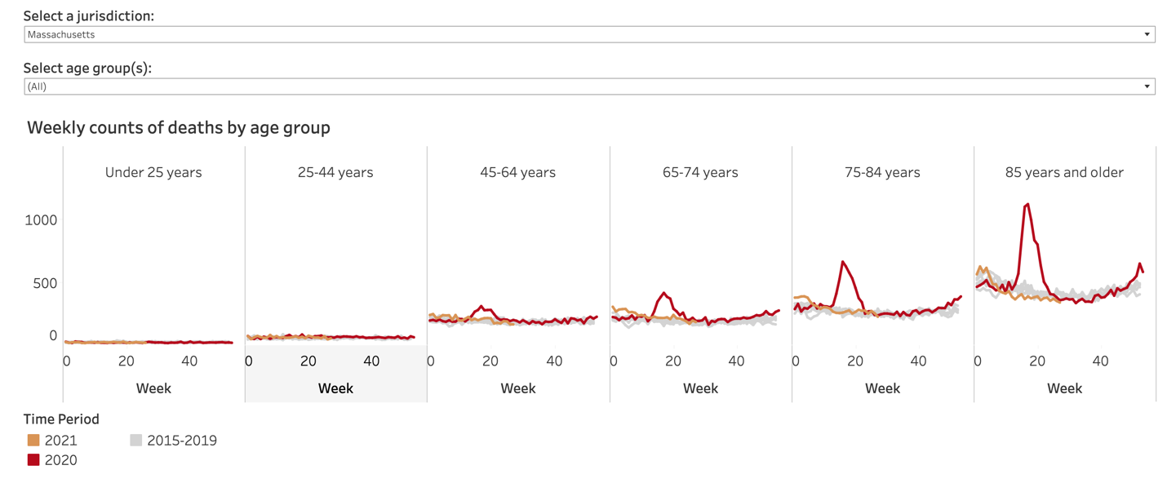

Finally, as you make your decisions, I hope that you will bear in mind the seasonal nature of this disease—otherwise, I believe you will be pressured to re-mask come fall—should you elect to make masks optional now. Even with extremely widespread vaccination, the seasonal patterns appear to persist (peaks in southern U.S. states were off by only 1 week from last year’s). In Iceland, where 75% of the population—i.e. all of the adult population—is completely vaccinated, the case rate is identical to ours in the U.S.. Again, this is not because the epidemic is being driven by un-vaccinated children—mathematically, it can’t be. This is because the vaccines while very effective at reducing severe illness and death, appear to be far less effective at limiting infection and transmission. Thus, should you choose to make masks a recommendation, rather than a requirement, I hope you will think about what course of action you will take when our inevitable winter case surge arrives. I hope you will elect to keep masks optional at that time, too, given their lack of impact on in-school transmission, and the efficacy of the vaccines in preventing serious disease in the at-risk population.

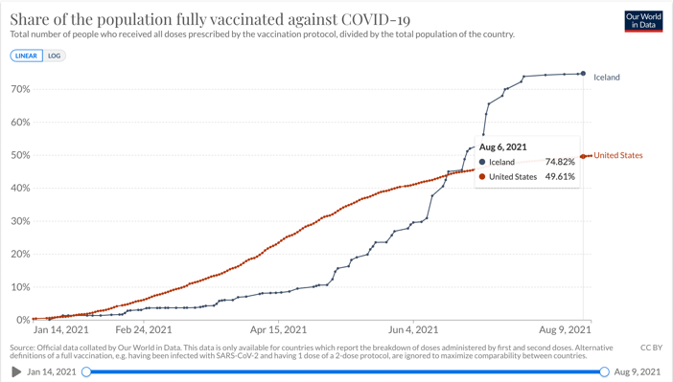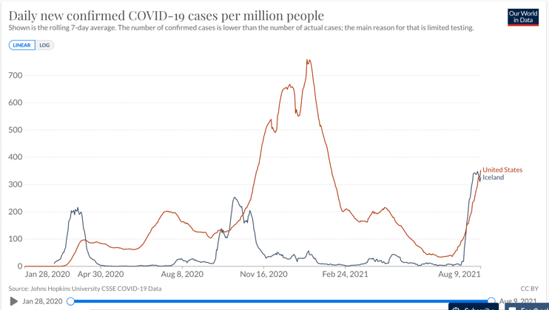

Thank you for taking the time to read this. I realize that this is a very fraught time, and I appreciate how challenging your position is. I hope that hearing as many perspectives as possible will help you in your decision-making process.

Sincerely,

[Your Name]

